# **LAB#02**

## **Objective: To become familiar with stream sockets.**

## Stream Socket Programming:

**Task 01**: **Compile and run the above code. Start the acceptor first and then the requestor with appropriate command line arguments. Describe and explain the output.**

**SERVER SOCKET**

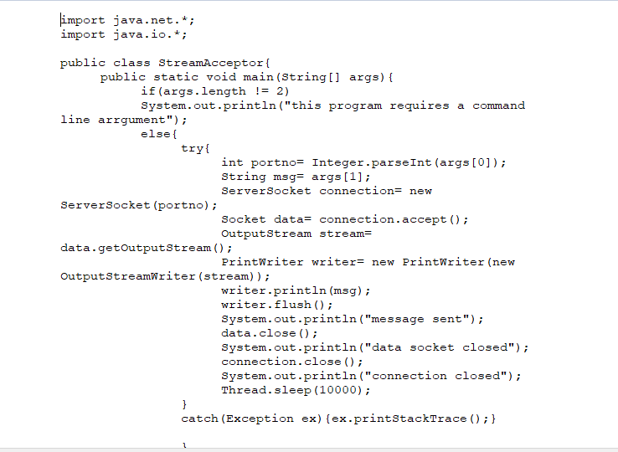

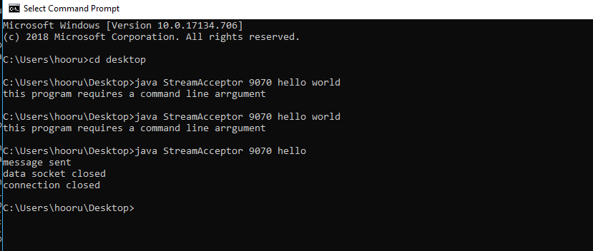

**CLIENT SOCKET**

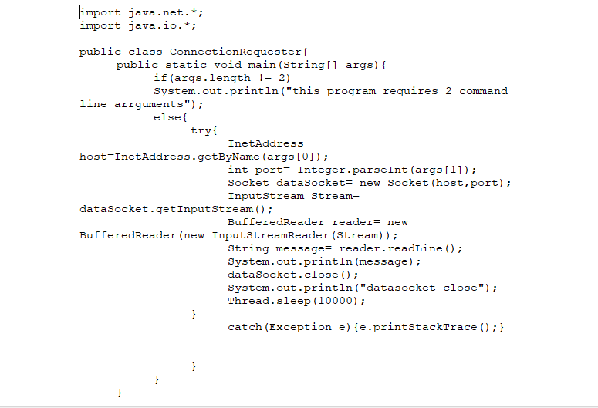

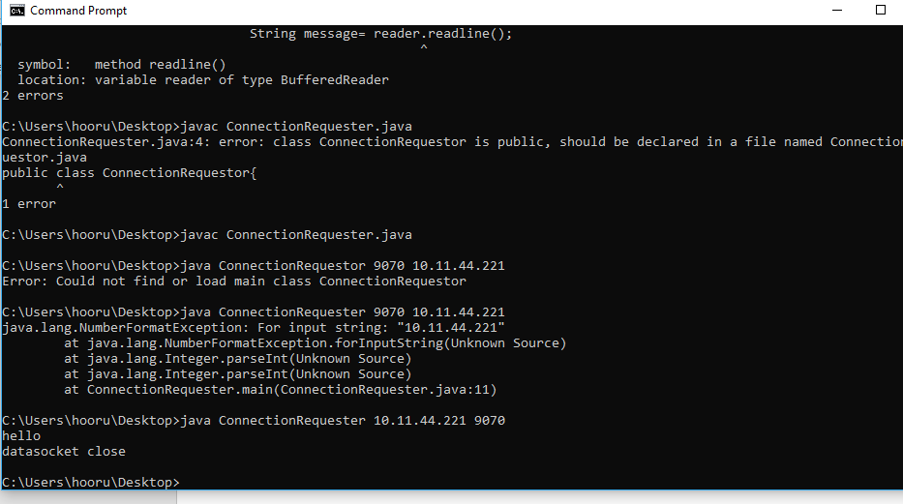

**Task 2: Now run the code again, but reverse the order of program’s execution. Start the requestor first and then the acceptor. Describe the outcome**

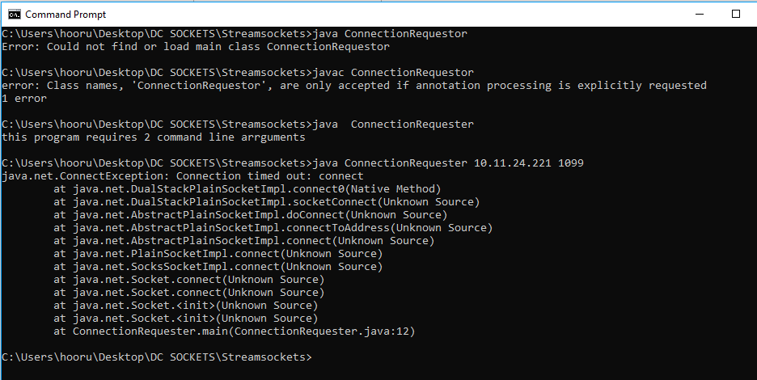

It is creating exception because there is no server that entertain the client request.

**Task 03: Modify the sample code to include two way communication between the client and the server.**

**Sender Class:**

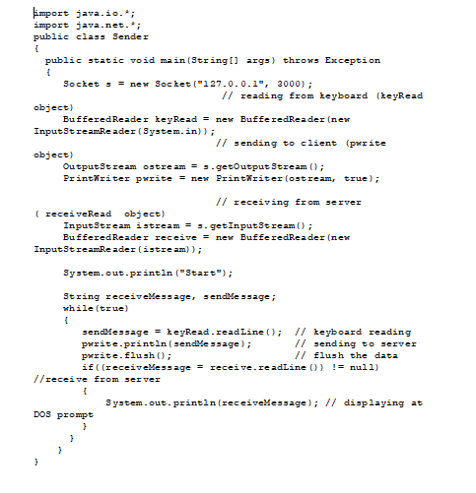

**Reciever class:**

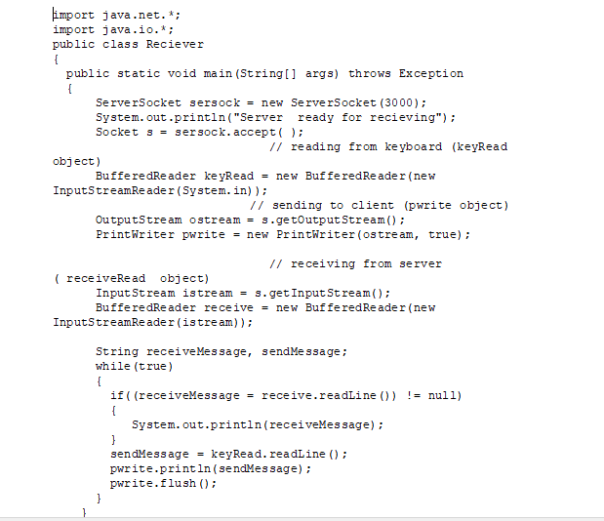

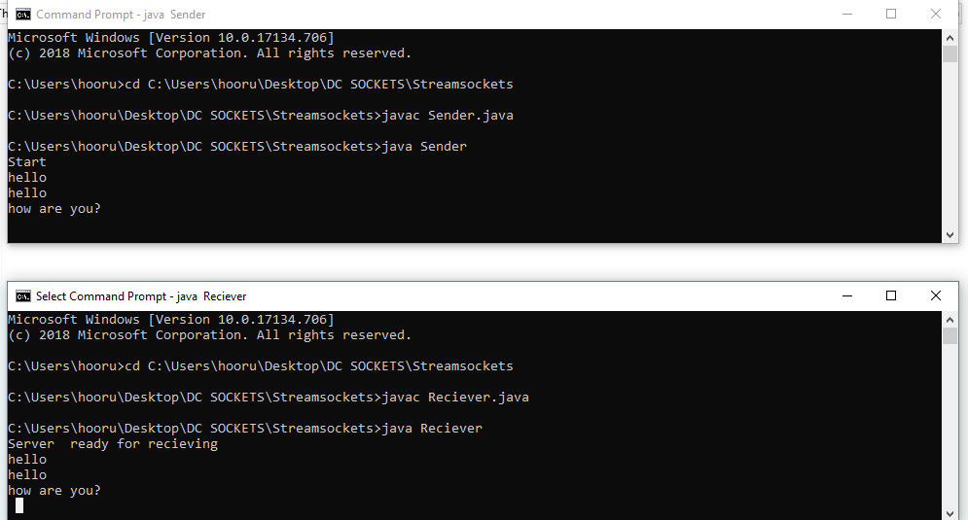

**Task 04: Modify the sample code to send complete files between the client to the server.**

**FileClient:**

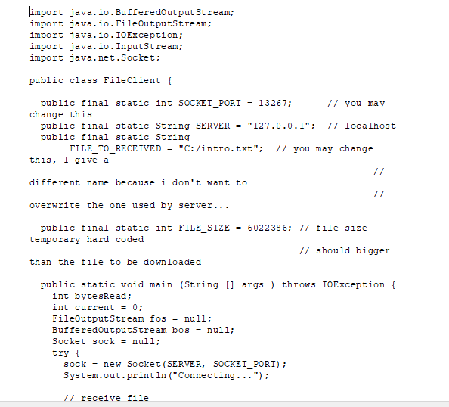

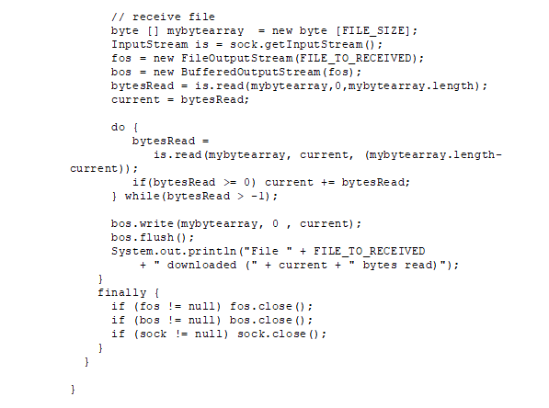

**FileServer:**

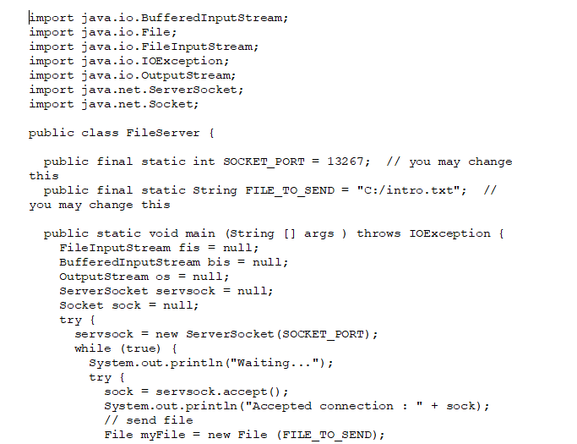

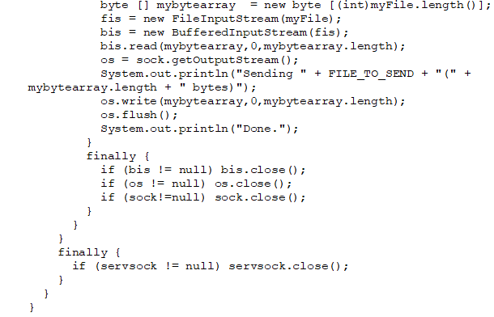

**Output:**

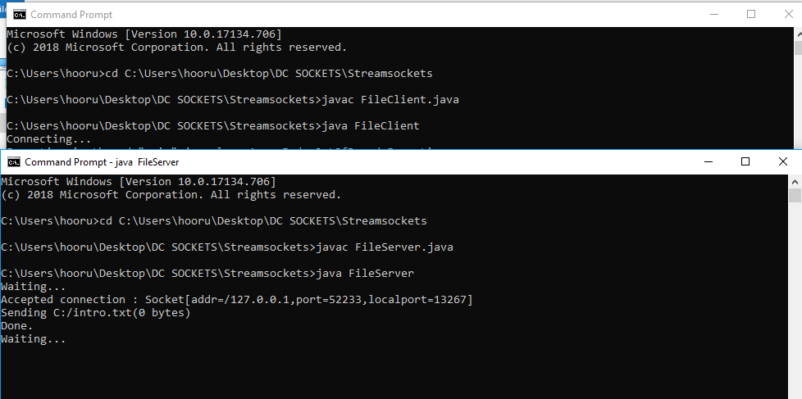

**Task 05: Exlore the non-blocking java socket API in the nio package and implement a sample program.**

**Server:**

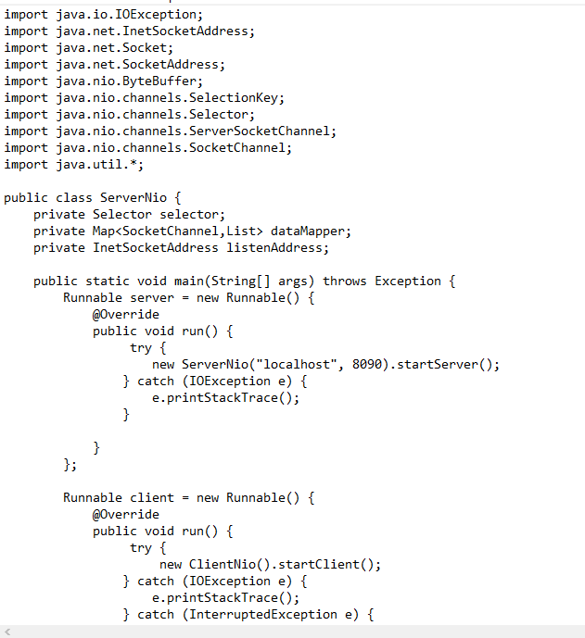

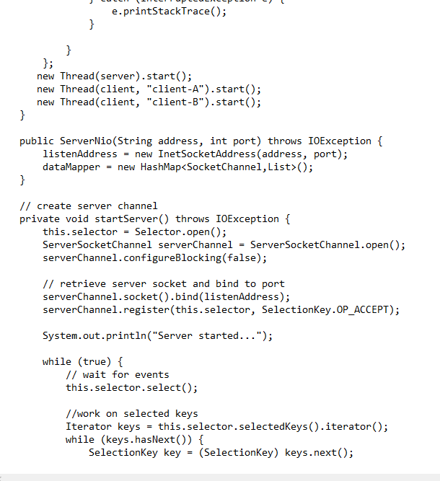

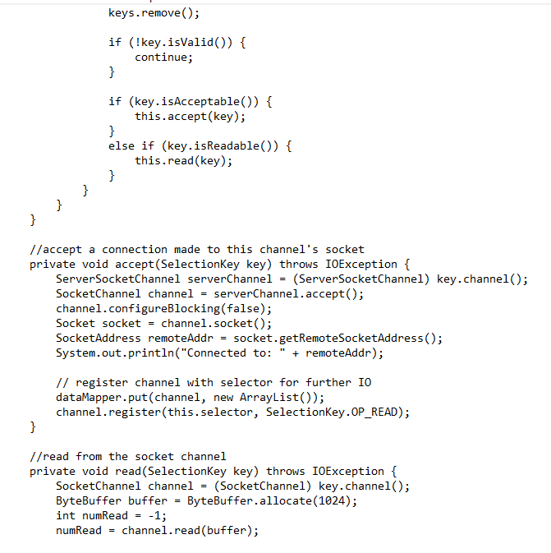

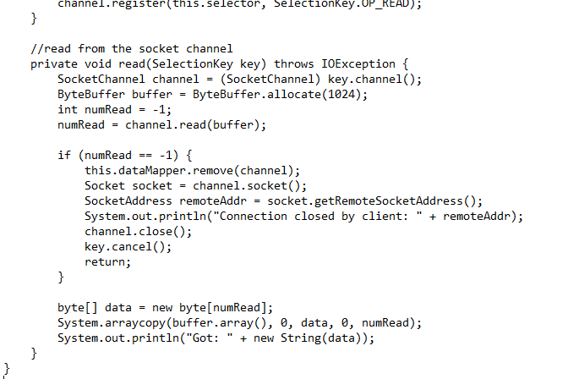

**ClientNio:**

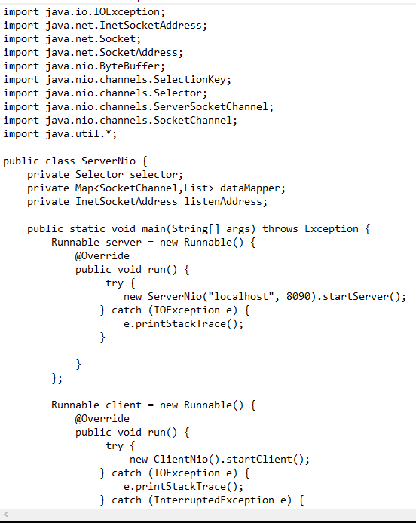

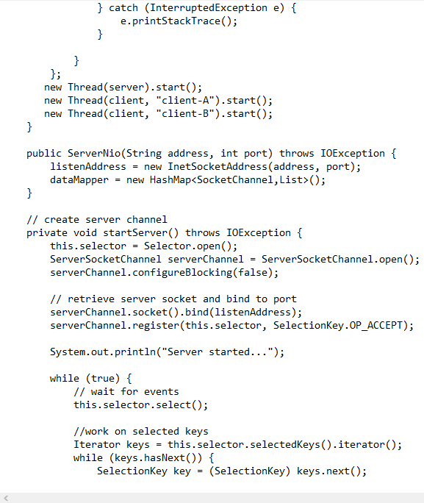

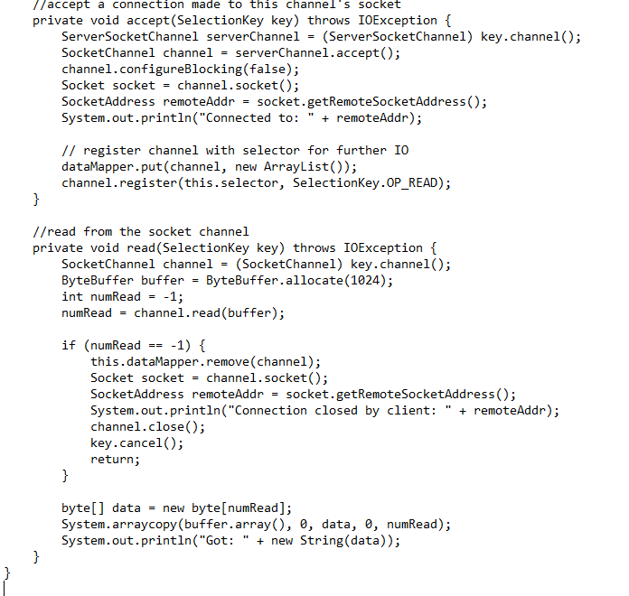

**Output:**

